Online Data Trending Application
Version 1.0
Draft
Online Data Trending Application 1
1 General 3
1.1 Overview 3
1.2 Development Process 3
1.3 Future Version Features 4
1.4 Key Players 4
1.5 Startup Costs 4
1.6 Domain Name 5
1.7 Hosting 5
1.8 Project Schedule 5
1.8.1 Engineering Schedule 5
1.8.2 Marketing Schedule 6
1.9 Legal Issues 6
1.10 Use Cases 6
1.10.1 Use Case #1 – Simple User 6
1.11 Notes/To do/Open issues 7
2 Marketing 7
2.1 Revenue Sources 7
2.1.1 Subscriptions 7
2.1.2 AdSense 7
2.1.3 Affiliate Marketing 8
2.1.3.1 Daily/Weekly Rank Emails 8
2.1.3.2 Direct Emails 8
2.2 Reasons for Subscribers to pay 8
2.2.1 Pricing 8
2.3 Competitive Analysis 9
2.3.1 Digital Point Analysis 9
2.3.2 Google Analytics Analysis 10
2.3.3 URLTrends.com Analysis 10
2.3.4 Competitor Feature Comparison: 10
2.3.5 Terms of Service 11
2.3.6 Privacy Policy 11
2.4 Website Design 12
2.4.1 Color Scheme 12
2.4.2 Site Logo 12
2.4.3 Site Hierarchy 12
2.4.4 Front Page 13
2.4.4.1 Screen Size 13
2.4.4.2 Front Page Text 13
2.4.5 Terms of Service 13
2.4.6 Sign-Up Process & Form 13
2.4.6.1 Welcome Email 14
2.4.6.2 Post-Sign-Up Landing Page 14
2.4.6.3 Maintenance Features 14
2.4.6.3.1 Make it easy to add videos. 14
2.5 Marketing Strategy / Advertising 14
2.5.1 Specific Advertising for Blogs 15
2.5.1.1 Blogger Icon / Banner 15
3 Engineering 15
3.1 Criteria (this will be integrated into other sections) 15
3.2 Third-Party Controls 16
3.3 Help/Documentation 16
3.4 User & Role Management 16
3.5 Email Engine Service 16
3.6 Rank Engine Service 17
3.6.1 What does it do? 17
3.6.2 Data Sources 17
3.6.3 Proxy Page 17
3.6.4 Proxy Tray Utility 18
3.7 Data Retrieval Architecture 18
3.7.1 Goals 18
3.7.2 Overview 18
3.7.3 Data Retrieval Process 19
3.7.4 Table Structure 19
3.8 Data Source Architecture 20
3.9 Scalability 20
3.10 Email Notification System 21
3.10.1 Email Template System 21
3.10.2 Email Template Editor 21
3.10.3 Required Email Templates 21
3.10.4 Email Engine Tokens 21
3.11 Build System 22
3.12 Installers 22
3.13 Parameter/Option Saving 22
4 User Interface 22
4.1 Documentation 22
4.2 Raw Data View 22
4.3 Summary Data View 23
4.3.1 Report Goals 23
4.3.2 Detailed Description 23
4.3.3 Chart Images 23
4.4 Saved Report Dashboard 24
4.4.1 Screen Overview 24
4.4.2 Public Dashboard 24
4.5 Rank Trending Control Layout 24
4.5.1 Overview 24
4.5.2 Tab Style 25
4.5.3 Appearance/Analysis Options 25
4.5.3.1 Goals for this Screen 26
4.5.3.2 Detailed Description 26
4.5.3.3 User Interface Items 26
4.5.3.4 Help/Documentation 27
4.5.3.5 Add Page / URL Dialog 27
4.5.4 Data Selection Options 28
4.5.4.1 Goals for this screen 28
4.5.4.2 User Interface Items 28
4.5.4.3 Detailed Description 29
4.5.5 Event Selection 30
4.5.5.1 Goals for this screen 30
4.5.5.2 User Interface Items 30
4.5.5.3 Detailed Description 30
4.5.6 Saved Reports 31
4.5.6.1 Detailed Description 31
4.5.6.2 How do I… 31
4.5.6.3 User Interface Items 31

General

Overview
There are many systems that give users vital statistics about their website traffic, revenue, advertising costs, hosting costs, etc. There is no known system that tracks all of these statistics, and provides meaningful information. A tool that unifies all of these data sources would be extremely valuable to webmasters, advertisers, and search engine optimizers.
Initially, this will only be a web application, but without the common limitations. It will be completely AJAX enabled, meaning that all inputs and updates are asynchronous. When the user changes an option, it will automatically appear on the chart once the chart is rendered. The UI should be able to keep up with even the most demanding users.

Development Process
The theme of this development process will be “well planned”. We need to think everything through, and know what will be available at launch. This will avoid delays that can occur when we find out that there were key features that we missed right before launch.
This specification document is the primary tool of the first development phase. After the specifications have been nailed down, the work from this document will be split up and entered into Fogbugz, where the items will be tracked to completion. We’re also going to improve our time predictability. We should be able to break everything down and give fairly accurate time estimates, so we know how long the project is going to take.

Future Version Features
These are listed because they were features considered for version 1.0, but are being pushed back to the next version. We can evaluate these again once we start on the next version.
- Can we import apache stats? Or should we have our own stat system?
- AWStats Proxy – import their logs and display in AWStats. Currently the only way to use AWStats is to do a command line install which requires access to the server. Most webmasters don’t have this access.
- Web service API
- Windows based app – this will allow us to easily sell it on ClickBank there by attracting more affiliate sales
- Automatically monitor sites for changes to things like the title, meta tags, etc.
- Affiliate Program – after a discussion with Joe, we decided that this is not required for version 1. We’re counting on viral marketing to build up a customer base, and then offer an affiliate program.
- Users should be able to configure alerts for certain things. For example, if their PageRank drops, or their rank drops significantly.
- Email filtering so that certain groups of users can be targeted when sending emails.
- Track rank in Digg.com, De.licio.us?
- Archive.org status
- DMOZ status
- User Forums – Allows users to help each other and discuss various topics. Google Adsense would be displayed for additional revenue. The login system would probably have to be independent.

Key Players
- Jason Young – Development and technical planning lead
- Joe Gerstl – Marketing, sales, and support
- Shawn Riesterer (tentative) – Development
- Patrick Brunson – Usability and concept consultant (customer perspective)
- 3rd party contractors – To be decided

Startup Costs
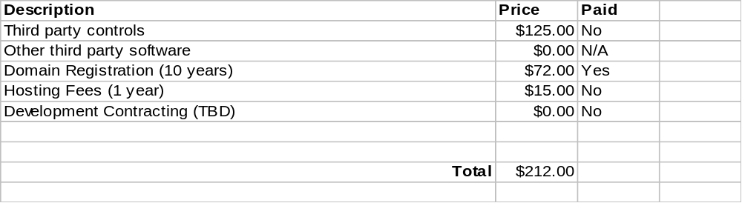

Domain Name
This has been discussed, and the chosen domain name is “RankTrend.com”. It has already been purchased and does not expire until May of 2016.

Hosting
The site will be hosted with Webhost4life. They have a track record of being able to successfully host ASP.NET 2.0 and SQL Server 2005 for a very reasonable price.

Project Schedule
The schedule is below and is broken up by department. It can be further broken down by person if we have multiple people working on it.

Engineering Schedule
The engineering schedule has been moved into its own Excel document.

Marketing Schedule
The engineering schedule has been moved into its own Excel document.

Legal Issues
All of the data that we can retrieve though the search engines API’s is perfectly legal. The biggest concern was that Google would not allow us to use the API key from multiple users. I (Jason) contacted Google and got permission specifically for this.
The only other piece of data that we need to retrieve that we don’t have specific permission for is Google PageRank. We need to make it clear to users that it is completely optional to check their PageRank. They can do so at their own risk.

Use Cases

Use Case #1 – Simple User
- User signs up with service by entering their email address and name.
- User gets a welcome email that contains their password.
- User logs into the system.
- User wants to set up their sites, so they start at the "Appearance/Analysis" tab, and click the "Add New Page" button.
- User wants to set up the keywords that they want the system to track, so they go to the "Data" tab. They click the "Add New".
- The user now waits for some data.
- The system emails the user that a month has gone by without them checking their rank results.
- The user logs back in, and finds that they have data to look at now.

Use Case #2 – Power User

- User signs up with service by entering their email address and name.
- User gets a welcome email that contains their password.
- User logs into the system.

Notes/To do/Open issues
- Do we want to store A/B testing stats? This would not take very long, but it’s probably worth scrapping at this point, unless someone (Joe) has a big objection.
- Shawn mentioned using more pictures of business people analyzing data, etc.
- We need to be able to have users set the size of the chart.
- Can we give the users a toolbar? Is it useful? Maybe we keep it mega simple, and it just has a print button, a save button, a make the image larger button, and a make the image smaller button.
- Come up with some other use cases based on the customers we expect.
- Think through a script that the user can put on their site that will track visitors and referrers.
- Data points should have hover help with timestamp and value
- Add scroll buttons to time range dialog
- Tree view icons for the data tab
- Under the "How do I", we'll have a search box
- Save charts - allow saving at a custom graph
- How do I - works with keywords. How do we choose what to display?

Marketing

Revenue Sources

Subscriptions
This will be the primary source of revenue. Free accounts will be enticed to upgrade to get more value from their stats. The biggest value will be the ability to log actions that they take (e.g. received a link from an authority site, published articles in the article directories, etc) and trend them against their visitors, AdSense revenue and sales numbers.

AdSense
AdSense will be displayed on pages of free accounts. In addition, users will be able to check their competitors from a button/link on a keyword graph. This will display a page of their competitors using Google Search – the AdSense ads that are displayed will automatically be related to their topic and this should compel our client to click on these ads to see what their competitors sites are like.
We may also want to consider a page that only displays the Google ads for a given keyword – don’t know if we can do this.

Affiliate Marketing

Daily/Weekly Rank Emails
Provide ads on each weekly rank email that we send.

Direct Emails
Market affiliate tools and other resources to subscribers based on their site type and possibly tracked keywords.

Reasons for Subscribers to pay
Of course for the site to be successful, it needs to make revenue. It is going to be very compelling for users to upgrade from the free account. The free account will be extremely limited (more so than NLE I would say). I would imagine that a customer could plot only a single track a single URL for each of their sites, and would have their ranking data updated automatically only on a weekly basis.
- Sub pages can be tracked in addition to the main website
- Data collection resolution - 1 day vs. 1 week
- Customizable/User defined event
- Import functions from Adwords, Adsense
- Emailed reports (should this be in this version? Need to figure out an easy way to do this)
- Multiple savable sets of options
- Monitor more URLs – The user may want to monitor multiple sites side-by-side, or even compare their performance to the competition.

When an option is not available for a user, it will be disabled, but still visible. The hover help will explain that they need to upgrade to receive that functionality.

Pricing
Free | - Can only plot Google and Yahoo (MSN?)  - Can only plot 1 data point per week, but can request manual data updates  - Limited to 5 URLs. Note: There is little concern about users signing up multiple sites, because it’s inconvenient, and doesn’t allow them to compare them side-by-side.  - Displays AdSense on all of the pages.
Value – $1.99/month | - Can plot rank from all search engines including PageRank  - Can plot global events (e.g. Google Dance, major Google update like Florida, Thanksgiving Day, etc)  - Import/Export capability  - 2 day resolution for data updates  - No adsense ads.  - Can track 20 URL’s  - Limited to 2 saved reports
Pro – 19.99/month | Value +  - Emailed report that includes the chart, and the raw data.  - Unlimited sub pages for each domain  - Can create custom events (e.g. obtained link from authority site, published article in article banks, etc)  - 1 day resolution for data updates  - Can save multiple sets of options.  - Can track 100 URL’s  - Unlimited saved reports
Pro Lifetime - $499.99 | Pro subscription that lasts as long as the service is around. We need to be clear that we do not guarantee the service will be available for a certain amount of time.

Competitive Analysis

Digital Point Analysis
http://www.digitalpoint.com/tools/keywords/
DigitalPoint is the closest competitor in terms of rank trending. They offer a way to check your rank in Google, Yahoo, and MSN Search. They allow users to use a Google API key to check their Google rank, and they have a proxy script that users can put on their server to track Yahoo and MSN. There are separate charts for Adsense and Adwords data.
DigitalPoint has the advantage of 50,000+ customers, a good base of SEO users. Their service is free, so at first it appears to be harder to lure users to another site. However, the users of the service have been asking for more such as automatic updates and layering of data. We’re in a position where we can give them what they are asking for, as well as some great features they didn’t even consider.
One of the big reasons that people are not happy with the DigitalPoint service is that it is manual. You are forced to visit their page every time you want to update your rankings. Users might go weeks or months without checking their rank, only to come back and have nothing to look at. They also have no frame of reference for the data. They don’t know when they made changes to their site, and how it relates to their rank. They can’t even correlate the adwords and adsense data. The charts for those must be viewed separately, which is inconvenient.

Google Analytics Analysis
http://www.google.com/analytics/
Google recently purchased an advanced website statistics package. The functionality is basically unmatched. They dropped the price after they acquired it, and now the basic version is completely free. Google has been sending out invitations to users to use the service. However, that is expected to change at some point, and anyone will be able to sign up for the service at will. The service has some advanced features over a regular statistical package such as location mapping, A/B testing, ad tracking, and more.
Google has the advantage of a massive and nearly unlimited customer base. Anyone doing SEO work is at least aware of the service. Their short term problem is that it is difficult to get an invitation to try it out. The long term problem is that they are owned by Google, so their data focuses on Google and the data that you can already get today. For example, they will help you integrate your Adwords data, but they will not show you ranking data. They will also most likely never show you, or support data from competing sites.
Google Analytics is seen as a great service, and we don’t dare compete with them. We need to watch them, and make sure that are services are complementary. We can focus on showing graphical representations of the users’ data, and correlate it from many sources. People tend to be visual, and we need to use that to our advantage to simplify all of this data.

URLTrends.com Analysis
http://www.URLTrends.com
URLTrends.com has been around since December of 2004, and has gained significant popularity. Their new page (http://www.urltrends.com/news.php) gives some insight as to how they have evolved over time. It’s a fairly small operation, and it appears as though the owner is hosting the site himself. He continually has to set up new hardware. The site has a PageRank of 6, which is very respectable, and shows the popularity of the service.
URLTrends.com offers services that are all over the board. They allow you to compare the stats of a site immediately, without signing up. This is a manual process, and seems only mildly useful. If you sign up, you get a dashboard style page that shows some key performance indicators such as PageRank and back link popularity. They also offer an API that allows other programs to access their data at a significant charge.
I contacted URLTrends.com and Google to find out if this was a legitimate service. According to Google, it’s against their terms of service. URLTrends.com said that they get the data through legitimate means whenever possible, and then mask their identity in other cases.

Competitor Feature Comparison:
 | Us | Digital Point | Google Analytics | URLTrends.com
Rank Trending | Yes | Yes | No | No
PageRank Tracking | Yes | Yes | No | Yes
Alexa Rank Tracking | No | No | No | Yes
Backlink Tracking | Yes | Yes | No | Yes
Adsense/Adwords Earnings | Yes | Yes | Yes | No
Combine data sources | Yes | No | No | No
Website Stats | No | No | Yes | No
CSV Export | No | No | Yes | Yes
Global Events | Yes | No | No | No
Custom Events | Yes | No | No* (campaigns) | No
Emailed Reports | Yes | No | No | Yes
Automatic | Yes | No | Yes | Yes
Affiliate Program | No | No | No | No
AJAX Enabled | Yes | No | No | No, but flash reports
Ambient Orb Enabled | No | Yes | No | No
All tracking integrated | Yes | No | No | No
Integrated with social bookmark sites. | No | No | No | Yes
RSS Feeds | No | No | No | Yes

Terms of Service
The terms of service needs to be written, and available on the website. Most likely, the TOS will be used from NaturalLinkExchange.com and modified in the specific cases where it is needed. We must make sure to strictly forbid reselling/repackaging of our service unless through a specific written agreement. The website template will include a link at the bottom.

Privacy Policy
The privacy policy needs to be written and available on the website. The website template will include a link at the bottom. We basically need to state the fact that we respect our users’ privacy, and we do not give away their information, or sell it to third parties. If we think there is a service they might be interested in, we will contact them directly. It also should not open us up to lawsuits if we decide to sell the information along with the entire site.

Website Design
We have evaluated a number of templates, and have decided on a very simple design (e.g. Google, URLTrend.com), that has an easy to use menu located at the top. The template is available for free at this address: http://www.oswd.org/design/preview/id/2876/
The template gives us a lot of room for pages that need it, and has a lot of white space so that it’s not very confusing. There will be a side bar, but it will only be visible on the front page. Other pages will need to have embedded navigation.

Color Scheme
Consistency is the key. We need to make it look the same on all the pages. This will provide a professional image and build credibility and comfort. I (Joe) like the URLTrend colors but of course we can’t steal them. Our site logo is orange and blue so this may be a good choice. We must make sure our icons blend into and go with what ever colors we choose.

Site Logo
GotLogos.com was used to create the logo for only $25. Joe may have suggestions for a better font for the word “Rank”, but this will be our default logo if no changes are made.


Site Hierarchy
The site should have some top level links that make it easy for users to navigate and learn about the service. The site hierarchy should resemble that of other sites so that users can easily find the information they are looking for that will sell the service.
- Features
  - Checks your site rank in all the major search engines every day
  - Enter events that you would like to track so that you can easily see what effect it has on your rank.
  - Correlate advertising dollars spent with the amount of money your site makes
  - Easy to set up system uses Google API key for Google ranking and back link checks.
  - Easy to set up ranking for other major search engines using a downloadable tray application, or a proxy page on your web server.
- Screenshots – Reinforce the feature list by having at least one screenshot of each one. There should be screenshots of every screen.
- Videos – This is discussed under the Help/Documentation section.
- Members – This will simply be a log-in page which takes the user to the main application.
- Link to Us – This will be a page that has a number of different ways to link to our site, and the HTML and instructions to do so. If someone wants to link to us, we want to make it easy.
- Plan Comparison – A page that has a table that compares all of the plan levels

Front Page
Make sure to list the benefits of the service. Features don’t influence until well after the prospect understands the benefits.
The front page of the website needs to send a quick and clear message about what we’re about. We need to have a minimal amount of text, and an animated GIF image to get our message across.

This is a list of all the frames that will be included in the animated GIF. The basic idea is to have some screenshots, along with a subtitle that tells the user what they are looking at.
Description | Subtitle
Screenshot of rank plotted on the chart. | Plot Your Rank Over Time
Screenshot of events being used. | Enter Events To See How Your Rank Is Affected.
Screenshots of Adsense/Adwords data included in chart. | Correlate Your Costs, Rank, And Revenue To Maximize Profits.

Screen Size
The site should be optimized for a 1024x768 screen. There are few enough users that use a lower resolution that we can basically ignore them. If they’re running at a lower resolution, they’re used to sites not working right.

Front Page Text
The benefits of tracking and trending your rank in relation to other activities, either individual or global, should be fully explained.

Terms of Service
We need to define our terms of service that users must agree to before we allow them to sign up for our service.

To do Joe: What does this need in it? I started the list
The terms of service should cover the following elements:
- Users are not allowed to pull data from our service in an automated fashion

Sign-Up Process & Form
To create an account, the user needs to put in their name, and email address. The welcome page will do the following:
- Show the user the terms of service, and require them to agree to them
- Get the users name and email address
- Ask the user what types of sites they would like to track. They can check as many as apply, and will include “Personal Blog”, “Work Blog”, “Business Website”, or “Personal Website”. We will not force them to check any of them.
- Tell the user that they will be receiving an email with their password and login instructions.
- After the user signs up, they will be taken to the post-sign-up landing page.

Welcome Email
When the user signs up, they will get an email that has the following items:
- Friendly greeting & welcome to the most powerful website trending tool
- Their automatically generated password
- Instructions on how to change their password
- Instructions to contact support if they did not intend to sign up for this service

Post-Sign-Up Landing Page
After the user signs up, they will go to this page, so that they know that the sign-up was successful. At this point we will tell them that they should check their inbox for the welcome email. If they do not get the email within 5 minutes, they should contact support. We should also thank them for signing up.

Maintenance Features
The site should be built to enable ease of maintenance.

Make it easy to add videos.
Build into the page template a DIV that becomes visible if a video is available for the page. The video should be detected by looking for a flash file that begins with the same name as the page in the same folder as the page. This will allow us to have multiple videos for each page. When visible, this DIV should show an image or a link so all we have to do is add a video to a folder.

Marketing Strategy / Advertising
The “cool factor” of this application is very high, and we should try to take advantage of this to promote viral marketing. Here is a list of our advertising targets:
- Digg.com – Social site where “cool” things are dugg and go to the front page. The front page can provide thousands of visitors in a single day. In addition, due to the high-tech nature of the readers, lots of people would blog about the product. Those people tend to have popular blogs, and the popularity ripples throughout the technical community.
- De.licio.us – Social site focused primarily on technology. Popular items get pushed to the front of the list like in Digg.com so casual browsers see them.
- BoingBoing.net – Similar to Digg.com, but the stories are approved by editors. Still a significant amount of traffic.
- Cross-promotions with NaturalLinkExchange.com. We can offer discounts or free subscriptions from users that are using the NaturalLinkExchange.com system.
- Email list advertising – We have had good success with advertising in SEO email newsletters. We will need to come up with a graphical ad that gets users attentions, and makes them want to check out our product.
- SEO forums – We need to make the SEO community aware of our new service by announcing it in the top SEO forums. (to-do: come up with a list)
- Press release – We should come up with a press release announcing the service. It is possible to submit the press release, and have it show up on Google news. (http://i-newswire.com/submit_free.php). We should also have the press release on the site for additional content.
- Domain resellers – our service can provide information that can make a domain more valuable to a prospective buyer. For instance if it’s already ranking well for a given term it will be worth more. See how URLTrends.com does it.
- Netscape Beta – Exact same concept as Digg.

Specific Advertising for Blogs
Bloggers are typically egocentric and are attracted to anything that they can add to their blog that indicates the value of the information and the readership of the blog. For example, http://www.business-opportunities.biz/projects/how-much-is-your-blog-worth/ has been used by many bloggers to help justify their advertising rates as well as simply give them some satisfaction.

Blogger Icon / Banner
Blogs are often set up with a list of small banner icons that tell visitors the kinds of technologies or services. They usually look similar to this:
On the website, where users can create a link to us, this will be one of the options. They can simply paste the HTML into their site. That will obviously give us the benefit of an incoming link for additional PageRank.
The icon will have a tiny line chart in the left part, and the text “RankTrend.com” on the right. If there is not enough room, it will simply be “RankTrend".
BlogTrend Thumbnail. Provide HTML for bloggers to display their rank for 1-5 keywords. They can place these thumbnails on individual blog pages so the keywords can be different based on topic. We may tap into RPC pings to do this (I don’t remember what this is about but it’s in my notes)

Engineering

Criteria (this will be integrated into other sections)
- URL
- Search terms
- Show/hide trend
- Metric (search engine + rank, etc)
- PageRank on/off
- Events

Third-Party Controls
- ChartDirector 4
- Peter’s Date Package ($50 – http://www.peterblum.com/datecontrols/TimeMain.aspx)
- MagicAjax.Net (Free – http://www.MagicAjax.net)
- CSVReader ($75 – http://www.csvreader.com)

Help/Documentation
- Dialog Videos – There will be extensive video help. Each dialog will have a link to a captivate demo for that particular set of options.
- Overview Video – We will have a quick (~1-2 minute) video introduction for people that have never seen this before. We want to quickly show them how valuable it can be to combine data from multiple sources for in-depth analysis. There should be a version with audio, and one without, so that first time users with slow connections can be convinced as quickly as possible.
- Quick help Message – Every control on every form will have a sentence or paragraph written describing how the user needs to use that particular field.

User & Role Management
For speed and simplicity, we will leverage the ASP.NET 2.0 Membership system. That will allow us to manage users and roles with almost no coding. That allows us to use the built in logon control, as well as the “forgot password” control.

Email Engine Service
The email engine service will be a polling service that simply polls the email queue, and sends emails that have not yet been sent. If an email fails to send, it will be marked as failed, and picked up at a later time. Emails will be reattempted on an exponential schedule. For example, they will be tried at 0 minutes, 1 minute, 2 minutes, 4 minutes, etc. That allows a minimal amount of attempts for almost any amount of down time.
Most of the email engine code will be copied from the NaturalLinkExchange.com project.
The email engine will also be responsible for replacing tokens in the emails that it sends. It will use the users ID associated with that email to load key information to substitute.

Rank Engine Service

What does it do?
- Retrieves data from remote servers either direct or through a webpage proxy. Its job is to retrieve data from all the data sources that a user has configured. It will have to be able to load the data sources, run them, and save the results.
- Schedule the data sources to run in a regular, but varying way. We don’t want to get all of the data for a site at the exact same time every day. It should be fairly random so that it does not look automated.
- Watch for certain conditions to be met, and queue emails based on those conditions. For example, a certain amount of time after a user signs up (say 2 weeks), we want to send them an email so that they have enough data available to see a nice chart. We’ll also want to watch for daily, weekly, or monthly emails that should be sent.

Data Sources
Available Through API – If “yes”, then the value can be retrieved from an API that the search engine provides
Proxied – If “yes”, then we will be using (and requiring) a proxy script on the clients machine (see “Proxy Page” section below).
Name | Available Through API | Proxied
Google Rank | Yes | No
Google PageRank | No | Yes
Google Backlinks | Yes | No
Yahoo Rank | Yes | Yes
MSN Search Rank | Yes | Yes
Google AdSense Data | Yes | No
Google AdWords Data | Yes | No

Proxy Page
Certain pieces of data cannot be retrieved on an unlimited basis. For example, you can only make 1000 API requests to Yahoo each day from a single IP address. We need to have a proxy page that users can put on their own server, so that we can use their IP address. This will make the requests look like they are coming from the users server, and will not look like an automated script.
The proxy page will need to be written in multiple languages to support he broadest customer range. The following languages will be supported in this version:
- PHP - Covers most Apache servers, and some IIS servers
- ASP - Covers most IIS servers
Refer to the table above to see which types of data will need to be retrieved from a proxy.
The proxy should be fairly generic so that it doesn’t need to be changed every time there is a new way to get PageRank and the other pieces of information. Contrast this to the way the competition handles this. Their script is very complicated, and is hard-coded to retrieve specific data. They have to do frequent updates to the script, which requires customers to go through the process of downloading the script, and getting it on their server.

Proxy Tray Utility
Many users either do not have a server where they can configure the proxy page, or they lack the skills or knowledge to do so. For those situations, we will have a utility that runs in the system tray, or a service that has a tray utility for status monitoring. The application basically queries our server for work to be done, and then reports back the results.

Goals:
- Just download and install without prompts
- Polls server to see if it has work to do
- Future expandability
- Automatic updating?
- Flash when rank is updated or other new information is available on RankTrend.com?
- Proxy aware What does this require?
- Fairly secure, so that only our client can make calls. When checking for queued jobs, get a key, run a hash, and use that for additional calls.
- Context menu with option "Go To RankTrend.com"
- Support for multiple computers simultaneously

Process:
- Client calls webservice, passes user GUID.
- Server returns a representation of the request the client should make. (what would that look like?) Note: a web request is NOT serializable in any way (XML, Soap, Binary)
- Client makes the request
- Client sends the response back to the server

Data Retrieval Architecture

Goals
- Separation of the criteria the user has selected. This allows us to save their settings, and easily test that object.
- Separation of the database and the data source logic so that the data source logic is easily testable.

Overview
- The UI will save data sources based on what the user wants to track.
- The data manager service periodically reads the “ConfiguredDataSources” table, and determines if a data source needs to be checked now. For example, it will check rank for a page if it has not been checked in the last 24 hours.
- When queued jobs are read from the database, they will be looked up by their unique key. The parameters will be given to the correct data source. The data source will then know how to get the data.
- After a job is run, the “LastRun” field will be updated for the configured data source, and the queued job will be deleted.
- Expired jobs will need to be purged by the data manager.

Data Retrieval Process
A visual representation of the process can be seen below. The criteria (aka “Saved Options”) are passed to the data retriever. The data retriever has the logic that is able to make the decisions about what data sources need to be created to get the information the user has requested. It uses the database access methods to interact with the database. Once all of the data is retrieved, it is sent back, and the process is complete.
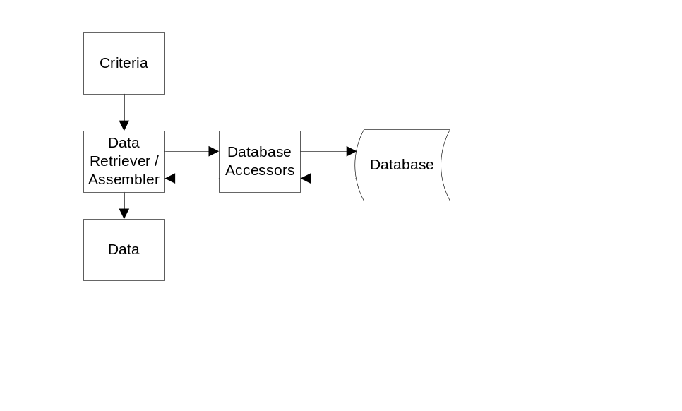

Table Structure
- ConfiguredDataSources
  - Id
  - PageId
  - DatasourceKey
  - SerializedParameters
  - ReadFrequencySeconds - The number of seconds between each data lookup. For example, rank would probably be read daily.
  - ReloadJobs - When set to true, the data manager will delete the existing jobs, and recreate any if necessary. This will be set to true when certain changes are made in the UI by the user.
  - LastRun - The last time the data source successfully ran. This will determine when it will be run next.
- QueuedDataSourceJobs
  - QueuedOn - The timestamp that this job was queued on. This should determine the priority in which the jobs are processed.
  - ConfiguredDataSourceId - The ID of the configured data source so that the parameters can be looked up.
  - ExpiresOn - The time that the data would no longer be valid, even if we could get it.
  - LastAttempt - The last time that the job attempted to run.
  - FailureCount - The number of times the job failed. This will be used to increase the time between retries.

Data Source Architecture
A data source must implement an interface that contains the following members:
- GetNextRequest() //Will return NULL if there are no more
- SetResponse(??)
- Name
- Description
- UNIQUE_KEY
- Parameters (get and set) - A class that represents the parameters that this data source needs.
- SerializedParameters (get and set) - The string representation of the parameters object for this data source.

Scalability
It is important to keep in mind the amount of data we could potentially be working with.

Factors | Potential Solutions
Database Size | - Have a plan to increase database capacity as needed  - Figure out a way to lower the resolution of old data, while still keeping the meaning intact. A possibility is to average old data as it ages. For example, you could average the values from 2 days of data into one point, that occurs in the middle of the original 2. You could continue with this algorithm down to a certain resolution (or lack thereof).
Raw data retrieval speed | - Determine correct indexes and table structure to optimize the common data retrieval operations.  - Consider the places where we can use asynchronous operations to each the load on the request threads.
Chart generation speed – This could become an issue if we update the chart frequently as a user changes their options. | - If the load issue is caused by consistent traffic, we’ll have to consider upgrading to a faster machine.  - Decrease the number of conditions that cause the chart to be refreshed. For example, add a refresh button(s).

Email Notification System
- Users should be notified when they have not been to the site in a long time.
- Send new users and email 1 month after signing up as a follow up, and to generate additional traffic.

Email Template System
The standard emails that will be sent to users will be based on templates. For example, when a new user signs up, we send them a welcome email. That email template will be loaded from the database, and will be inserted into the email queue for that user. The email engine will be responsible for replacing all of the tokens before sending.

Email Template Editor
The administrative menu will include an option to edit the email templates. This will be similar to that of the NLE site. It will have the following features:
- A drop down list of email templates – There will not be a way to add or remove templates from this page. That will be done in the database.
- A subject text field
- A message field that allows an HTML message to be entered and tokens to be used for replacement when sending.
- A list of available tokens, with examples.
- Instructions on how to clean up the message so that there are no bizarre characters or formatting.

Required Email Templates
- Welcome email
- Inactivity email
- Sign-up follow-up email

Email Engine Tokens
- Home page link – A complete HTML hyperlink to the front page of the main website.
- Home page URL – The URL of the website.
- Terms of Service link – A complete HTML hyperlink to the terms of service page.
- Logo with link to the site – A complete HTML hyperlink with the site logo, which points to the website.
- User’s full name – The complete name that the user signed up with.

Build System
Builds will be created using an NAnt build script, and executed automatically by the CruiseControl.NET infrastructure currently in place. Builds will be run every time a checking is made in the source repository.

Installers
Since the primary application is a web application, no installer will be created. The Visual Studio 2005 web publishing system will be used to create the output files.
The service(s) will use the WIX toolkit for building the installers. That will allow for easy development, testing, and deployment to the production server.
Installers will need to be created for the following projects:
- Email Engine
- Rank Engine

Parameter/Option Saving
There are a lot of configurable options for the rank trending. Once a user chooses the settings they want, they are probably going to want to reuse them. That means that when they leave the application and then return, it will remember the options that they used last. Along the same lines, they will be able to save a specific set of options, view them in a list, and reload them.
The most flexible method of storing the options is by using XML. To avoid manually reading and writing the XML, we’ll use a serializable object that contains all of the settings the user wants to save. We can then save them to a Varchar(MAX) column in the database.

User Interface

Documentation
To do Joe: What additional documentation will we have?
- FAQ (Frequently asked questions)

Raw Data View
Raw Values (export) (copy to clipboard)
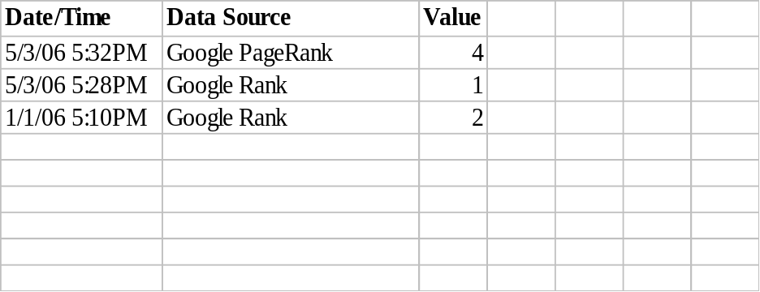
To do: do we want to allow sorting or paging? What would that take?

Summary Data View
Summary (export) (copy to clipboard)
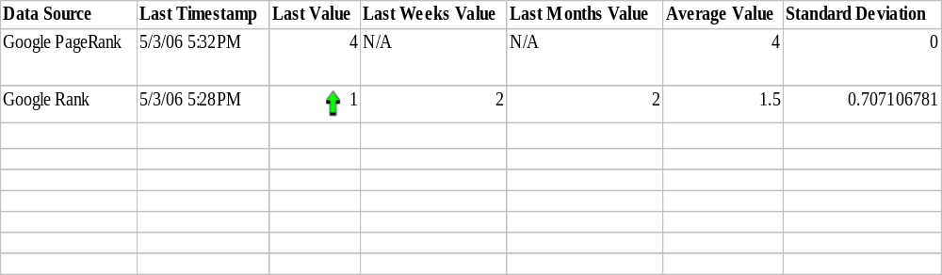

Report Goals
To Do

Detailed Description
This report is to address a specific feature offered in the Digital Point solution (see competitors). Their primary view of your data is in a nice looking table format. We don’t want this to be a hurdle to switching to our service. We should show what is really necessary, and try to provide some additional analysis for the statistically inclined. As you can see, this includes the average and standard deviation. That will give them a baseline as to where they are at, and will also tell them how predictable it is.

Chart Images
Here are the arrow images that can be used to show if a value has increased or decreased. There are visual queues for those that will understand what the colors mean, and there is also the obviousness of the up/down shapes.

Report Menu Control
This will be an option off the Control Panel and will be named Report Menu. The screen mocked up below is the first screen of the report display and setup process. If the user doesn’t have a default dashboard selected (see the Dashboard Menu), this display will be opened initially. 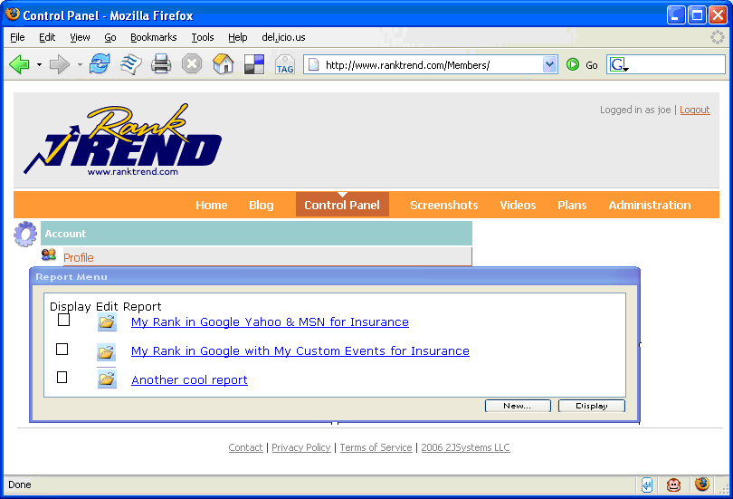It serves 3 primary purposes. 1) Provides a way for users to add new reports (through the Add button). 2) Lists all the reports users have created. 3) Provides a way for users to select reports to display – either individually or multiple reports at once.
To add a new report the user would click the New… button which would take them to the Rank Trending Control.
If the user clicks on the Edit icon or clicks the reports hyperlink, it would also take them to the Rank Trending Control which would be loaded with the selected reports current settings.
If the user clicks on 1 or more check boxes, then clicks the Display button. The Display button should be disabled until at least 1 check box is checked. Make sure to disable it if a single checkbox is checked then unchecked. Once the user selects 1 or more reports and clicks the Display button they will be taken to the Save Report Dashboard window.

Dashboard Menu Control (v2?)
The reports that users select from the Report Menu end up in a dashboard. Users can have multiple dashboards limited to the number allowed by the plan they select. A dashboard menu will be displayed off the Control Panel. Similar to Report Menu, the user can perform 3 functions from this menu.
1. By selecting one of the radio buttons next to a dashboard, the user can select this as their default and the user will be transferred to this dashboard upon their initial login. They will be placed in this dash board via the Saved Dashboard Display. If a default dashboard is selected, upon login the user should be taken directly to this dashboard.
2. To clear the default, the user can click the Clear Default button.
3. Clicking on either the Edit icon or the dashboard hyperlink, the user will be placed in to edit mode on the dashboard via the Saved Dashboard Display.
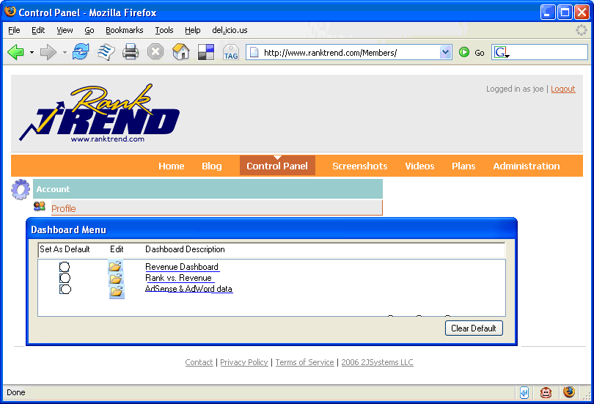

There should be a system & uneditable dashboard that has all of the saved reports listed on it.

Saved Report Dashboard

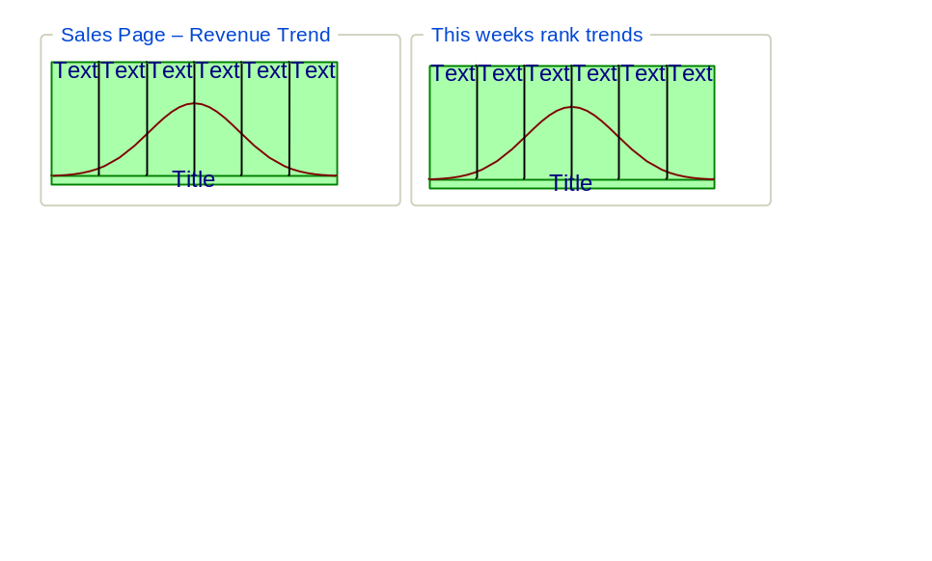

Screen Overview

Version 1

Saved Dashboard
This page serves as a quick place that a user can visit to view all of their saved reports. They can use the “Saved” tab of the rank tool to specify which saved reports show up on this report. By default, a report WILL show up on this report.
The reports will all be the same size, and they will take up as much horizontal width as possible. In other words, the charts will wrap based on the users screen size. Normally, they would probably see about 2-3 reports in each row. The user should be able to easily hyperlink to this page.
Each report will have a title above it, based on the name that the user gave it. If they hover over the title, the description will be displayed. When the user clicks on a chart, it will take them to the Rank Trending Control page, and pre-load the options from that report. That will make it easy to drill-down from the dashboard, into report editing mode.

Public Dashboard
To allow users to share statistics, they can mark saved reports as “Public”. If they have at least one saved report marked as “Public”, they can then allow others to view the reports, using a different dashboard URL, marked as public.
The users will learn about this feature through the “How do I...” menu, which will appear on their dashboard page, and will also show up when looking at saved reports, and when managing saved reports.

Version 2
Allow users to create multiple dashboards made up of reports that they specifically select for the dashboard. They would be able to arrange in the order they like. They would also be able to designate a dashboard as “Public”.

Rank Trending Control Layout

Overview
The general layout will have the chart at the top, and the tabbed options below. That will allow the chart to be controlled quickly and easily while seeing the chart and the controls at the same time.
To do: Do we want to have a tab just for upgrading their account?
To do: Add configuration dialog? Or Wizards?

Tab Style
The tabs will look like the above image. There are icons for cool-factor, and for faster association. The text is as simple as possible so there is no confusion. I’m including the prototype HTML used to generate the above tabs. I’m also including a file that contains all of the original icons that were modified to work in the tabs.

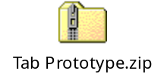

Appearance/Analysis Options
This is the initial screen that will be displayed for the rank trending. This is where users will quickly be able to choose the site that they are analyzing. It will also offer a quick way to look at the raw data as well as the line chart.

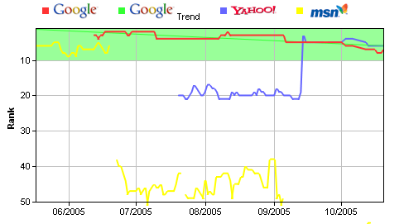

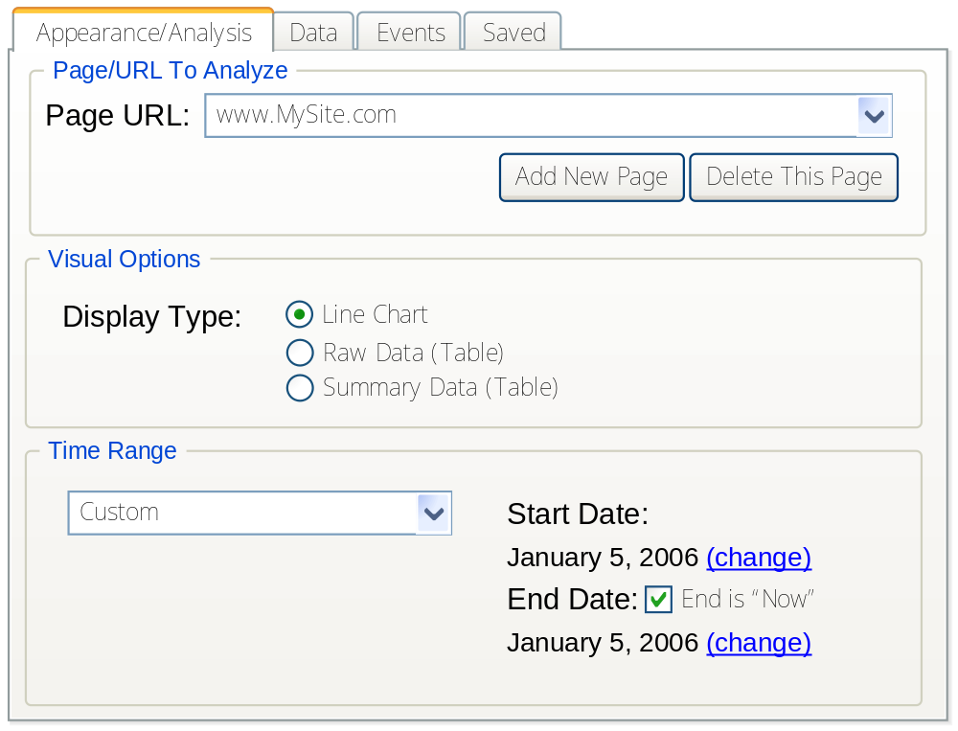

Goals for this Screen
- Choose the format of the data you’re viewing (chart type, raw data, etc)
- Choose the page to analyze
- Add/Remove pages
- Change/view the time range

Detailed Description
This tab will be the default tab, because it will allow users to quickly look over all of their sites. The other tabs would probably not be visited on as frequent a basis. The other tabs would have the users previous settings pre-selected.
When the user clicks on the “Save Current Options” button, they will be taken to the “Saved” tab. The “Saved” tab will give the report a unique name (probably based on the time), and will show the details for the current report in edit mode.

User Interface Items
Name | Description
Page URL | Chooses the URL that the user would like to analyze.
Add New Page | Adds a new page to the users list of pages.
Delete This Page
Line Chart
Raw Data
Summary Data
Time range drop down | When “Custom” is selected, the time range shows the last 30 days. If they save it, the time range will be stored absolutely. They can also choose preset amounts of time, and the manual time range will be disabled. However, it will be updated

Help/Documentation
- Inform the user that they cannot edit pages. They can only add or delete them. This is because stored data is only valid for that URL.
- Give a detailed hover description for each display type. A small mockup, icon, or screenshot within the dynamic help could also be very useful.
- In the default dynamic help area, in addition to describing what the page does, it should tell the user that they can go to the “Saved” tab to save their options.

Add Page / URL Dialog
This is the dialog that will be used when the user wants to add a new site a new page to track.

To do: What will this look like? It was going to be a pop-up, but we don’t want pop-ups.

Data Selection Options
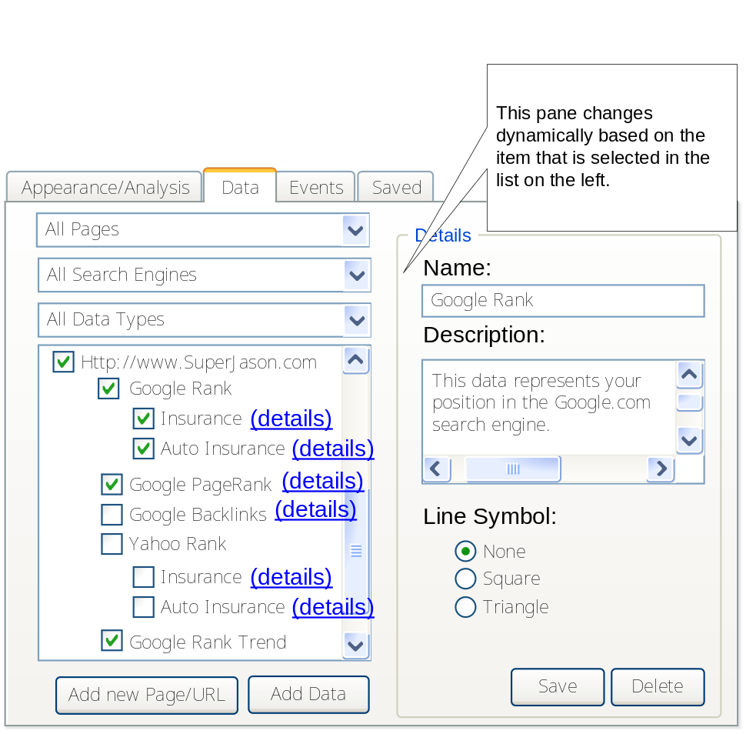

Goals for this screen
- Allow user to add/delete/update the types of data they can display.
- Allow the user to choose what data they want to display on the chart.

User Interface Items
Name | Description
Search Engine Filter | This is a filter that allows the user to choose a search engine, and only view the datasources associated with that search engine.
Data Type Filter
Datasource List
Add New
Name | Displays the name of the data source. This is read-only if it’s one of the base data sources in the system, otherwise the user can edit it if it’s their own data source.  To do: does this make sense?
Description
Line Symbol – None | The data points on the chart will not have a symbol, they will simply be connected.
Line Symbol – Square | Each data point on the chart will have a square symbol, which will make it easier to see where each data point lies.
Line Symbol – Triangle | Each data point on the chart will have a triangle symbol, which will make it easier to see where each data point lies.

Detailed Description
To do: Add mock-ups for all the variations of the “details” pane.
This screen needs to be able to allow the user to choose the data they want to look at extremely fast. They will also be able to look at the details about each type of data they are going to plot. We will need to describe each data source. They can filter the data sources by search engine, and by data type. Data types include Ranks, Trends, and Other. To look at the details, the user can either click “details” for that item.
From a technical standpoint, this functionality is simple. .NET 2.0 has a TreeView control that supports nodes with checkboxes, and also supports clicking on the TreeView node text, and it will fire a server event. This is where we would update the details pane.
When a user wants to add a keyword to track, they will click “Add New”. The details pane will then have a drop down list where the user will select a type such as Yahoo Rank, Google PageRank, etc. Once they choose the type, the rest of the details pane will be displayed, and will have fields for the type that they selected. For example, if they choose “Yahoo Rank” for the type, they will have a field that allows them to enter the keywords.

Event Selection
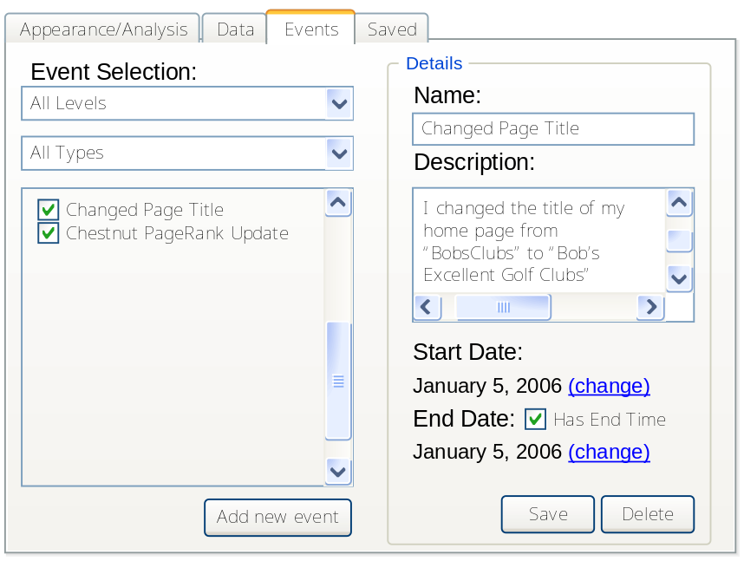

Goals for this screen
- Allow the user to add/update/delete their events
- Allow the user to choose the events that they want to show on the chart.

User Interface Items
Name | Description
Level Filter
Type Filter
Event List
Add new event
Name
Description
Start Date
End Date
Save
Delete

Detailed Description
This dialog will allow the customers to display custom events that they define, or display global events that are present for all users. They will be able to filter the event list based on the level (Global or Custom), and the type (Page Change, PageRank update, etc). It should be easy to edit the users’ custom events. Events can be a single point in time, or they can have duration with a start and end time.

Saved Reports
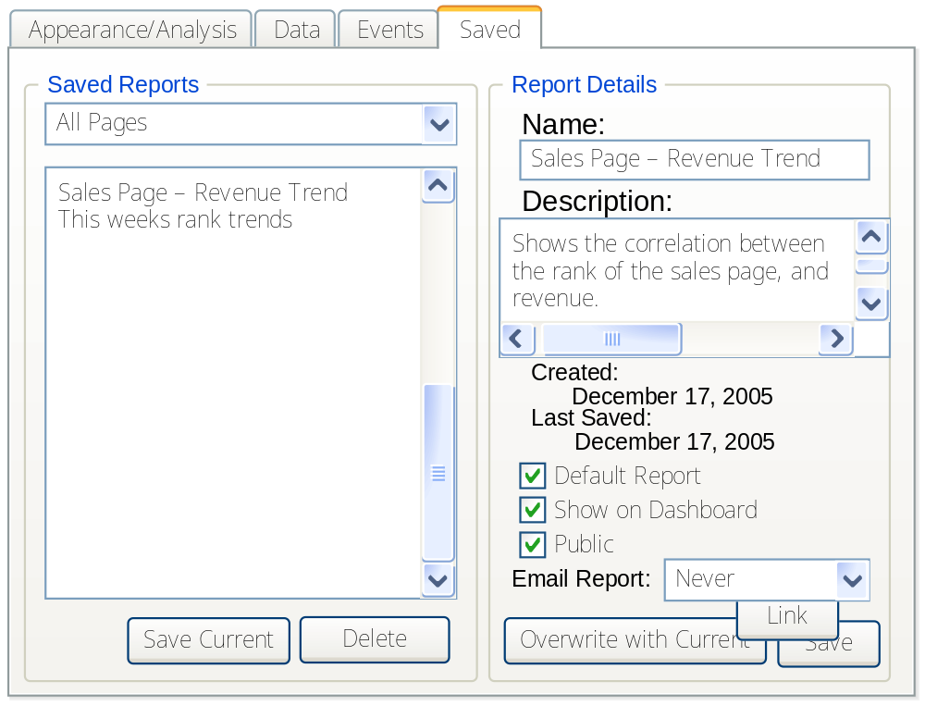

Detailed Description
This screen is designed to make it easy to manage (create, add, delete) saved reports.

How do I…
We need to have a menu for this page with a title of “How do I…” that lists the common questions that people may have. Here is a list of topics:
- Link to a saved report on my website
- Create a new saved report
- Updated a saved report that already exists

User Interface Items
Name | Description
Save Current | Saves the current options from the other tabs, and creates a new, automatically named report
Delete | Deletes the selected report
Name | The title that the user assigns to this report
Description | The description that the user gives to this report
Created | The date/time that the report was created. This can never be changed.
Last Saved | The date/time that the report options were last saved.
Default Report | If checked, this is the set of options that will be used when the user first visits on the rank trending page. Only 1 report can be defined as the default report. We should warn the user when checking this, so that they know that their previous default will no longer be the default. The first report created will be the initial default.
Show on Dashboard | If this option is selected, it will be included in the dashboard screen(s).
Public | If this option is selected, it will show up on the users’ public dashboard.
Email Report | Sets how often this saved report will be emailed to the user. The choices are “Every Day”, “Every Week”, “Every 2 Weeks”, and “Every Month”.
Overwrite with Current Options | Uses the current options from the other tabs, and overwrites the currently selected report.
Link | Generates a permanent link to the report. This will basically have one parameter, which will be the GUID of the saved report.
Save | Will save the users options from the pane on the right side in the above diagram.

